WEEK 1: ALGORITHMS AND DATA STRUCTURES

Exercise 2: E-commerce Platform Search Function

Scenario: To work on the search functionality of an e-commerce platform with optimized performance.
Understand Asymptotic Notation:
Explain Big O notation and how it helps in analyzing algorithms.
Big O notation is a mathematical representation used to describe the upper bound of an algorithm's running time or space requirements in terms of the size of the input data. It also helps in analyzing the efficiency of algorithms by providing an approximation of the worst-case scenario in terms scales as the input size increases. This allows developers to predict performance and make informed decisions about which algorithms to use.
Big O Notation helps in analyzing the Algorithms
- Performance Prediction: Predicts how an algorithm scales with input size, guiding suitability for large datasets.
- Algorithm Comparison: Standardizes efficiency comparison, e.g., O(n log n) vs. O(n^2).
- Scalability: Assesses how well an algorithm handles larger inputs.
- Optimization: Guides code optimization by highlighting less efficient algorithms.
- Worst-Case Analysis: Ensures the system can handle the algorithm's maximum resource needs.

Describe the best, average, and worst-case scenarios for search operations.
Best, Average, and Worst-Case Scenarios for Search Operations
- Best Case: This is the best-case scenario where the search operation completes in the shortest possible time, usually when the desired element is at the beginning of the collection.
- Average Case: The scenario of average case, represents a typical run where the position of the desired element is uniformly distributed in the list of elements.
- Worst Case: The scenario of worst case is where the search operation takes the longest time, this is usually considered when the desired element is at the end of the collection or not present in the list at all.

Setup:
Create a product class
(Product.java)
public class Product {
private String productId;
private String productName;
private String category;
public Product(String productId, String productName, String category) {
this.productId = productId;
this.productName = productName;
this.category = category;
}
public String getProductId() {
return productId;
}
public String getProductName() {
return productName;
}
public String getCategory() {
return category;
} @Override
public String toString() {
return "Product ID: " + productId + ", Name: " + productName + ", Category: " + category;
}
}
Implementation:
(SearchAlgorithms.java)
import java.util.Arrays;
import java.util.Comparator;
public class SearchAlgorithms {
public static Product linearSearch(Product[] products, String productName) {
for (Product product : products) {
if (product.getProductName().equalsIgnoreCase(productName)) {
return product;
}
}
return null;
}
public static Product binarySearch(Product[] products, String productName) {
Arrays.sort(products, Comparator.comparing(Product::getProductName));
int left = 0;
int right = products.length - 1;
while (left <= right) {
int mid = left + (right - left) / 2;
int comparison = products[mid].getProductName().compareToIgnoreCase(productName);
if (comparison == 0) {
return products[mid];
} else if (comparison < 0) {
left = mid + 1;
} else {
right = mid - 1;
}
}
return null;
}
}
(Main.java )
public class Main {
public static void main(String[] args) {
Product[] products = {
new Product("P001", "Laptop", "Electronics"),
new Product("P002", "Smartphone", "Electronics"),
new Product("P003", "Tablet", "Electronics"),
new Product("P004", "Monitor", "Electronics"),
new Product("P005", "Keyboard", "Accessories")
};
System.out.println("Linear Search:");
String searchName = "Tablet";
Product foundProduct = SearchAlgorithms.linearSearch(products, searchName);
if (foundProduct != null) {
System.out.println("Found: " + foundProduct);
} else {
System.out.println("Product not found.");
}
System.out.println("\nBinary Search:");
searchName = "Monitor";
foundProduct = SearchAlgorithms.binarySearch(products, searchName);
if (foundProduct != null) {
System.out.println("Found: " + foundProduct);
} else {
System.out.println("Product not found.");
}
}
}

Output:
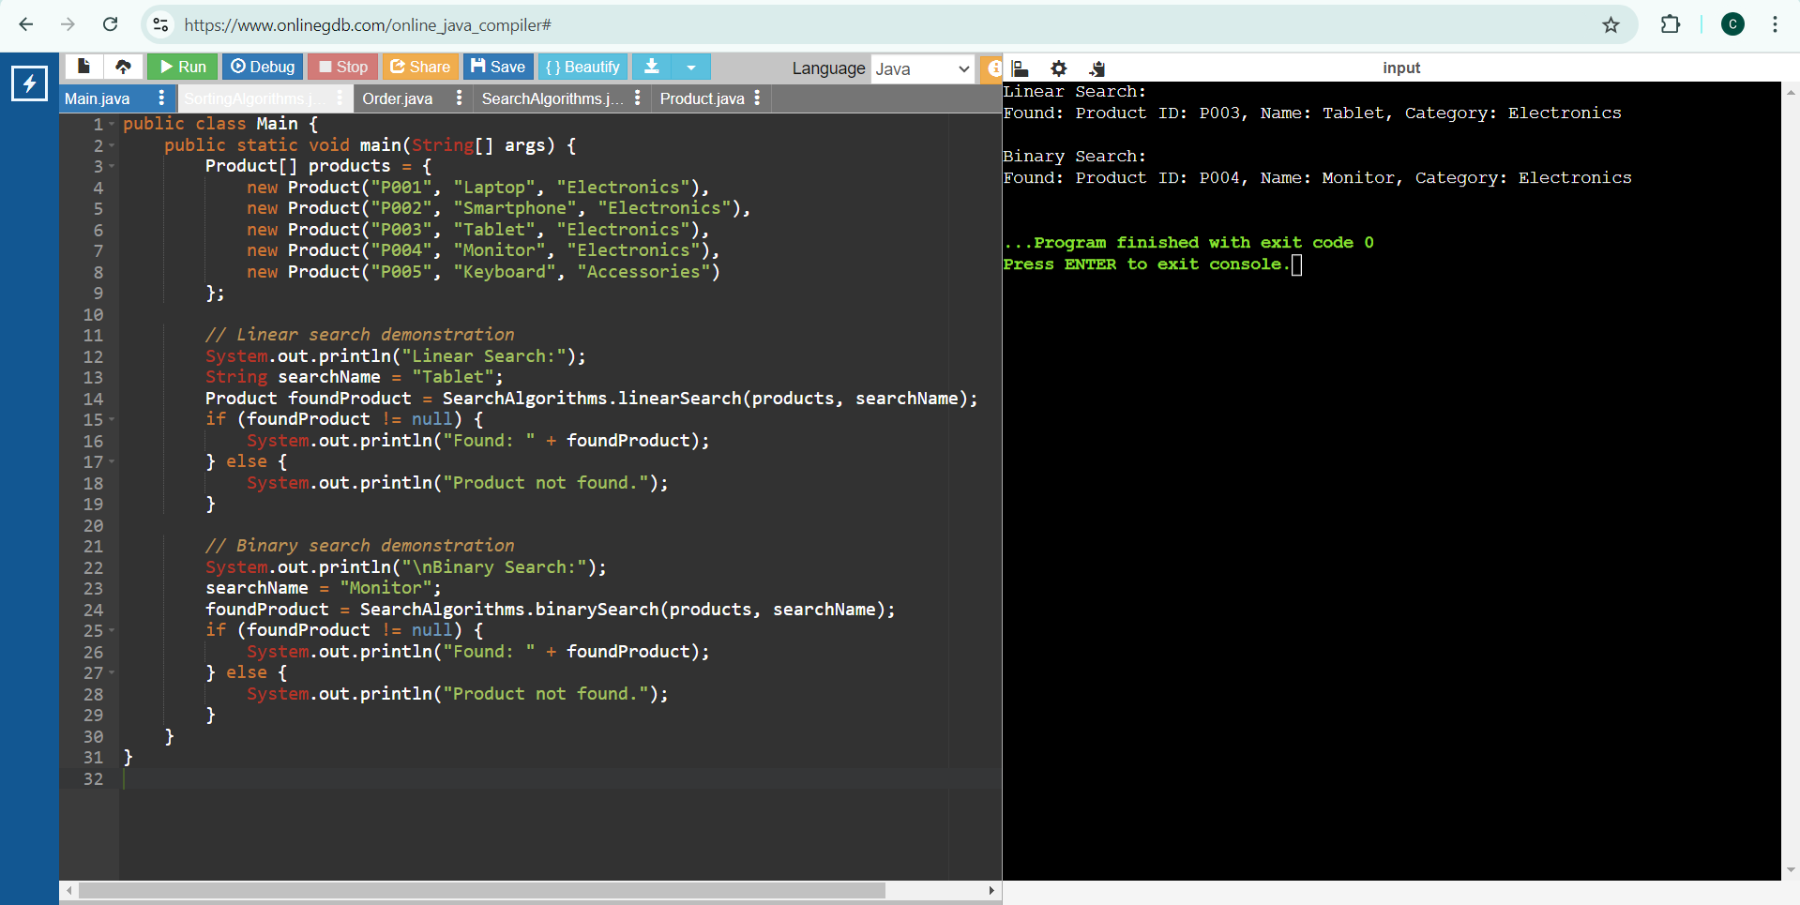
Time Complexity:
Linear Search:
- Best Case: O(1) (when the element is at the beginning)
- Average Case: O(n)
- Worst Case: O(n)
Binary Search:
- Best Case: O(1) (when the element is at the middle)
- Average Case: O(log n)
- Worst Case: O(log n)
Suitable Algorithm for this Platform:
Binary search is more suitable for the e-commerce platform because it has a lower time complexity of O(log n) compared to linear search O(n) for large datasets. However, it requires the dataset to be sorted. If the dataset is not sorted or frequently updated, linear search might be simpler to implement initially but less efficient for larger datasets.

Exercise 7: Financial Forecasting

Scenario: To develop a financial forecasting tool that predicts future values based on past data.
Understand Recursive Algorithms
Concept of Recursion
Recursion is a technique where a function calls itself to solve smaller instances of the same problem. It can simplify complex problems by breaking them down into more manageable subproblems.
- Base Case: The condition under which the recursion stops.
- Recursive Case: The part of the function where it calls itself with a smaller or simpler input.
- Advantages:
  - Simplifies code for problems that have repetitive structures.
  - Often more intuitive for problems like tree traversal, factorial calculation, etc.
- Disadvantages:
  - Can lead to excessive memory use due to function call stack.
  - Potential for stack overflow if not properly controlled.
Setup
Create a method to calculate the future value using a recursive approach
//Demonstration of the future value using resursion
public class FinancialForecasting {
public static double future_val(double present_val, double growthRate, int periods) {
// Base case is used if no periods left, return present value
if (periods == 0) {
return present_val;
}
// Recursion approach is used apply growth rate to present value and reduce the period
return future_val(present_val * (1 + growthRate), growthRate, periods - 1);
}

Implementation
Recursive Algorithm to Predict Future Values
(FinancialForecasting.java)
public class FinancialForecasting {
public static double future_val(double present_val, double growthRate, int periods) {
if (periods == 0) {
return present_val;
}
return future_val(present_val * (1 + growthRate), growthRate, periods - 1);
}
public static void main(String[] args) {
double present_val = 1000.0;
double growthRate = 0.05; // 5% growth rate
int periods = 9;
System.out.println("Present Value: $" + present_val);
double futureValue = future_val(present_val, growthRate, periods);
System.out.println("Predicted Future Value: $" + futureValue);
}
}
Output:
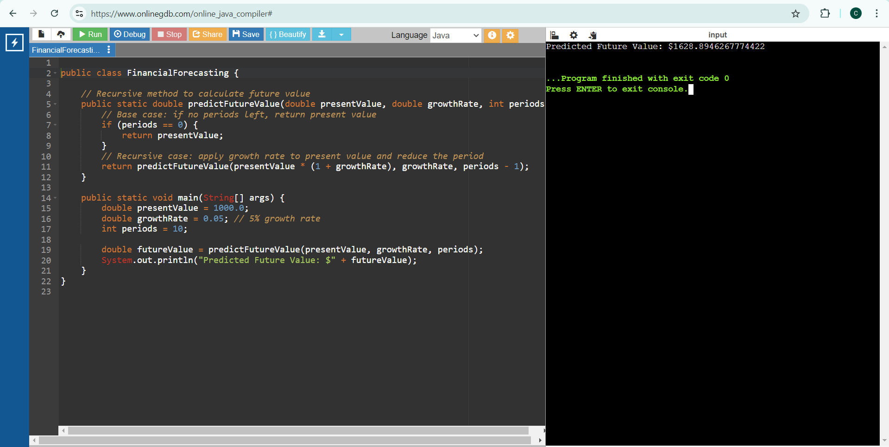
Analysis
Time Complexity of Recursive Algorithm
- Time Complexity: O(n), where n is the number of periods.
  - Each call to the function handles one period, leading to n recursive calls.
- Space Complexity: O(n), due to the function call stack. Each recursive call adds a new frame to the stack.
Optimizing the Recursive Solution
To avoid excessive computation and potential stack overflow, we can use memoization to store previously computed results. Memoization is not necessary in simple growth rate model, as each step depends only on the previous step and does not repeat subproblems.

